

**INTRODUCCIÓN AL CÁLCULO-MA611- Kick off UPC EPE y WS**

**2021-0-2**

**TAREA 01**

**Nombre y Apellidos ______________________________________________**

1. Determine el conjunto solución de:
2.  (2,5 puntos)

|  |  |  |  |  |  |  |  |  |  |  |  |  |  |  |  |  |  |  |  |  |  |  |  |  |
| --- | --- | --- | --- | --- | --- | --- | --- | --- | --- | --- | --- | --- | --- | --- | --- | --- | --- | --- | --- | --- | --- | --- | --- | --- |
|  |  |  |  |  |  |  |  |  |  |  |  |  |  |  |  |  |  |  |  |  |  |  |  |  |
|  |  |  |  |  |  |  |  |  |  |  |  |  |  |  |  |  |  |  |  |  |  |  |  |  |
|  |  |  |  |  |  |  |  |  |  |  |  |  |  |  |  |  |  |  |  |  |  |  |  |  |
|  |  |  |  |  |  |  |  |  |  |  |  |  |  |  |  |  |  |  |  |  |  |  |  |  |
|  |  |  |  |  |  |  |  |  |  |  |  |  |  |  |  |  |  |  |  |  |  |  |  |  |
|  |  |  |  |  |  |  |  |  |  |  |  |  |  |  |  |  |  |  |  |  |  |  |  |  |
|  |  |  |  |  |  |  |  |  |  |  |  |  |  |  |  |  |  |  |  |  |  |  |  |  |
|  |  |  |  |  |  |  |  |  |  |  |  |  |  |  |  |  |  |  |  |  |  |  |  |  |
|  |  |  |  |  |  |  |  |  |  |  |  |  |  |  |  |  |  |  |  |  |  |  |  |  |
|  |  |  |  |  |  |  |  |  |  |  |  |  |  |  |  |  |  |  |  |  |  |  |  |  |
|  |  |  |  |  |  |  |  |  |  |  |  |  |  |  |  |  |  |  |  |  |  |  |  |  |
|  |  |  |  |  |  |  |  |  |  |  |  |  |  |  |  |  |  |  |  |  |  |  |  |  |
|  |  |  |  |  |  |  |  |  |  |  |  |  |  |  |  |  |  |  |  |  |  |  |  |  |
|  |  |  |  |  |  |  |  |  |  |  |  |  |  |  |  |  |  |  |  |  |  |  |  |  |
|  |  |  |  |  |  |  |  |  |  |  |  |  |  |  |  |  |  |  |  |  |  |  |  |  |
|  |  |  |  |  |  |  |  |  |  |  |  |  |  |  |  |  |  |  |  |  |  |  |  |  |

1.  (2,5 puntos)

|  |  |  |  |  |  |  |  |  |  |  |  |  |  |  |  |  |  |  |  |  |  |  |  |  |
| --- | --- | --- | --- | --- | --- | --- | --- | --- | --- | --- | --- | --- | --- | --- | --- | --- | --- | --- | --- | --- | --- | --- | --- | --- |
|  |  |  |  |  |  |  |  |  |  |  |  |  |  |  |  |  |  |  |  |  |  |  |  |  |
|  |  |  |  |  |  |  |  |  |  |  |  |  |  |  |  |  |  |  |  |  |  |  |  |  |
|  |  |  |  |  |  |  |  |  |  |  |  |  |  |  |  |  |  |  |  |  |  |  |  |  |
|  |  |  |  |  |  |  |  |  |  |  |  |  |  |  |  |  |  |  |  |  |  |  |  |  |
|  |  |  |  |  |  |  |  |  |  |  |  |  |  |  |  |  |  |  |  |  |  |  |  |  |
|  |  |  |  |  |  |  |  |  |  |  |  |  |  |  |  |  |  |  |  |  |  |  |  |  |
|  |  |  |  |  |  |  |  |  |  |  |  |  |  |  |  |  |  |  |  |  |  |  |  |  |
|  |  |  |  |  |  |  |  |  |  |  |  |  |  |  |  |  |  |  |  |  |  |  |  |  |
|  |  |  |  |  |  |  |  |  |  |  |  |  |  |  |  |  |  |  |  |  |  |  |  |  |
|  |  |  |  |  |  |  |  |  |  |  |  |  |  |  |  |  |  |  |  |  |  |  |  |  |
|  |  |  |  |  |  |  |  |  |  |  |  |  |  |  |  |  |  |  |  |  |  |  |  |  |
|  |  |  |  |  |  |  |  |  |  |  |  |  |  |  |  |  |  |  |  |  |  |  |  |  |
|  |  |  |  |  |  |  |  |  |  |  |  |  |  |  |  |  |  |  |  |  |  |  |  |  |
|  |  |  |  |  |  |  |  |  |  |  |  |  |  |  |  |  |  |  |  |  |  |  |  |  |

1. Dados los conjuntos:

  y C = {-2; -1; 0; 1; 2; 3}

Determine y sombree la región que corresponde a:

 = { _____________________}

(3 puntos)

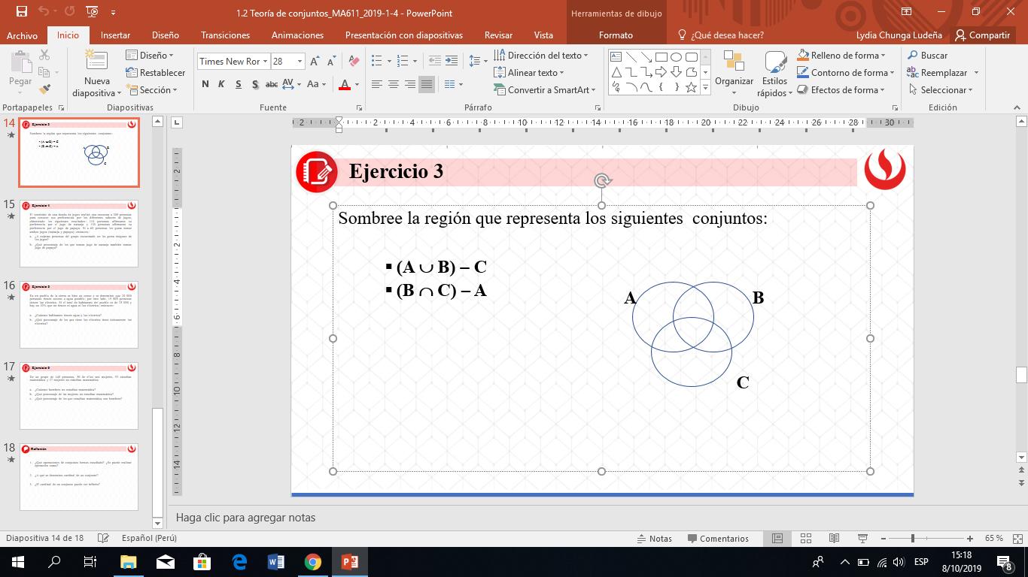

|  |  |  |  |  |  |  |  |  |  |  |  |  |  |  |  |  |  |  |  |  |  |  |  |  |
| --- | --- | --- | --- | --- | --- | --- | --- | --- | --- | --- | --- | --- | --- | --- | --- | --- | --- | --- | --- | --- | --- | --- | --- | --- |
|  |  |  |  |  |  |  |  |  |  |  |  |  |  |  |  |  |  |  |  |  |  |  |  |  |
|  |  |  |  |  |  |  |  |  |  |  |  |  |  |  |  |  |  |  |  |  |  |  |  |  |
|  |  |  |  |  |  |  |  |  |  |  |  |  |  |  |  |  |  |  |  |  |  |  |  |  |
|  |  |  |  |  |  |  |  |  |  |  |  |  |  |  |  |  |  |  |  |  |  |  |  |  |
|  |  |  |  |  |  |  |  |  |  |  |  |  |  |  |  |  |  |  |  |  |  |  |  |  |
|  |  |  |  |  |  |  |  |  |  |  |  |  |  |  |  |  |  |  |  |  |  |  |  |  |
|  |  |  |  |  |  |  |  |  |  |  |  |  |  |  |  |  |  |  |  |  |  |  |  |  |
|  |  |  |  |  |  |  |  |  |  |  |  |  |  |  |  |  |  |  |  |  |  |  |  |  |
|  |  |  |  |  |  |  |  |  |  |  |  |  |  |  |  |  |  |  |  |  |  |  |  |  |
|  |  |  |  |  |  |  |  |  |  |  |  |  |  |  |  |  |  |  |  |  |  |  |  |  |

1. David Rosales es el jefe de sección de una empresa de servicios eléctricos. Los empleados de su sección se encargan de podar los árboles cuando crecen demasiado, escalar postes y unir cables. Recientemente, Rosales presentó el siguiente reporte a la gerencia de la empresa:

*Mi sección incluye:*

$T=$*el conjunto de empleados que pueden podar árboles muy altos.*

$P=$*el conjunto de empleados que pueden escalar postes.*

$W=$*el conjunto de empleados que pueden unir cables.*

$$n\left(T\right)=45$$

$$n\left(P\right)=50$$

$$n\left(W\right)=57$$

$$n\left(T∩P\right)=28$$

$$n\left(P∩W\right)=20$$

$$n\left(T∩W\right)=25$$

$$n\left(T∩P∩W\right)=11$$

$$n\left(T^{c}∩P^{c}∩W^{c}\right)=9$$

La información proporcionada por Rosales se encuentra representada por la siguiente figura.

**U**

**T**

**P**

**W**

1. Complete el diagrama anterior. (2 puntos)
2. Determine el número de empleados de la sección. (2 puntos)

|  |  |  |  |  |  |  |  |  |  |  |  |  |  |  |  |  |  |  |  |  |  |  |  |  |
| --- | --- | --- | --- | --- | --- | --- | --- | --- | --- | --- | --- | --- | --- | --- | --- | --- | --- | --- | --- | --- | --- | --- | --- | --- |
|  |  |  |  |  |  |  |  |  |  |  |  |  |  |  |  |  |  |  |  |  |  |  |  |  |
|  |  |  |  |  |  |  |  |  |  |  |  |  |  |  |  |  |  |  |  |  |  |  |  |  |
|  |  |  |  |  |  |  |  |  |  |  |  |  |  |  |  |  |  |  |  |  |  |  |  |  |
|  |  |  |  |  |  |  |  |  |  |  |  |  |  |  |  |  |  |  |  |  |  |  |  |  |
|  |  |  |  |  |  |  |  |  |  |  |  |  |  |  |  |  |  |  |  |  |  |  |  |  |
|  |  |  |  |  |  |  |  |  |  |  |  |  |  |  |  |  |  |  |  |  |  |  |  |  |
|  |  |  |  |  |  |  |  |  |  |  |  |  |  |  |  |  |  |  |  |  |  |  |  |  |
|  |  |  |  |  |  |  |  |  |  |  |  |  |  |  |  |  |  |  |  |  |  |  |  |  |
|  |  |  |  |  |  |  |  |  |  |  |  |  |  |  |  |  |  |  |  |  |  |  |  |  |
|  |  |  |  |  |  |  |  |  |  |  |  |  |  |  |  |  |  |  |  |  |  |  |  |  |

1. De 80 estudiantes de una institución educativa, se sabe que:

27 están en la asignatura A, pero no en la asignatura B.

26 están en la asignatura B, pero no en la asignatura C.

19 están en la asignatura C, pero no en la asignatura A.

2 estudiantes están en las tres asignaturas mencionadas. ¿Cuántos estudiantes llevan otras asignaturas? (4,0 puntos)

|  |  |  |  |  |  |  |  |  |  |  |  |  |  |  |  |  |  |  |  |  |  |  |  |  |
| --- | --- | --- | --- | --- | --- | --- | --- | --- | --- | --- | --- | --- | --- | --- | --- | --- | --- | --- | --- | --- | --- | --- | --- | --- |
|  |  |  |  |  |  |  |  |  |  |  |  |  |  |  |  |  |  |  |  |  |  |  |  |  |
|  |  |  |  |  |  |  |  |  |  |  |  |  |  |  |  |  |  |  |  |  |  |  |  |  |
|  |  |  |  |  |  |  |  |  |  |  |  |  |  |  |  |  |  |  |  |  |  |  |  |  |
|  |  |  |  |  |  |  |  |  |  |  |  |  |  |  |  |  |  |  |  |  |  |  |  |  |
|  |  |  |  |  |  |  |  |  |  |  |  |  |  |  |  |  |  |  |  |  |  |  |  |  |
|  |  |  |  |  |  |  |  |  |  |  |  |  |  |  |  |  |  |  |  |  |  |  |  |  |
|  |  |  |  |  |  |  |  |  |  |  |  |  |  |  |  |  |  |  |  |  |  |  |  |  |
|  |  |  |  |  |  |  |  |  |  |  |  |  |  |  |  |  |  |  |  |  |  |  |  |  |
|  |  |  |  |  |  |  |  |  |  |  |  |  |  |  |  |  |  |  |  |  |  |  |  |  |
|  |  |  |  |  |  |  |  |  |  |  |  |  |  |  |  |  |  |  |  |  |  |  |  |  |
|  |  |  |  |  |  |  |  |  |  |  |  |  |  |  |  |  |  |  |  |  |  |  |  |  |
|  |  |  |  |  |  |  |  |  |  |  |  |  |  |  |  |  |  |  |  |  |  |  |  |  |
|  |  |  |  |  |  |  |  |  |  |  |  |  |  |  |  |  |  |  |  |  |  |  |  |  |
|  |  |  |  |  |  |  |  |  |  |  |  |  |  |  |  |  |  |  |  |  |  |  |  |  |

1. En cierta universidad, el 50% de los estudiantes aprobó Cálculo, el 42% aprobó Lenguaje y el 56% aprobó uno y sólo uno de los dos cursos. Además, 432 estudiantes aprobaron Cálculo y Lenguaje. ¿Cuántas estudiantes hay en dicha universidad? (4,0 puntos)

|  |  |  |  |  |  |  |  |  |  |  |  |  |  |  |  |  |  |  |  |  |  |  |  |  |
| --- | --- | --- | --- | --- | --- | --- | --- | --- | --- | --- | --- | --- | --- | --- | --- | --- | --- | --- | --- | --- | --- | --- | --- | --- |
|  |  |  |  |  |  |  |  |  |  |  |  |  |  |  |  |  |  |  |  |  |  |  |  |  |
|  |  |  |  |  |  |  |  |  |  |  |  |  |  |  |  |  |  |  |  |  |  |  |  |  |
|  |  |  |  |  |  |  |  |  |  |  |  |  |  |  |  |  |  |  |  |  |  |  |  |  |
|  |  |  |  |  |  |  |  |  |  |  |  |  |  |  |  |  |  |  |  |  |  |  |  |  |
|  |  |  |  |  |  |  |  |  |  |  |  |  |  |  |  |  |  |  |  |  |  |  |  |  |
|  |  |  |  |  |  |  |  |  |  |  |  |  |  |  |  |  |  |  |  |  |  |  |  |  |
|  |  |  |  |  |  |  |  |  |  |  |  |  |  |  |  |  |  |  |  |  |  |  |  |  |
|  |  |  |  |  |  |  |  |  |  |  |  |  |  |  |  |  |  |  |  |  |  |  |  |  |
|  |  |  |  |  |  |  |  |  |  |  |  |  |  |  |  |  |  |  |  |  |  |  |  |  |
|  |  |  |  |  |  |  |  |  |  |  |  |  |  |  |  |  |  |  |  |  |  |  |  |  |
|  |  |  |  |  |  |  |  |  |  |  |  |  |  |  |  |  |  |  |  |  |  |  |  |  |
|  |  |  |  |  |  |  |  |  |  |  |  |  |  |  |  |  |  |  |  |  |  |  |  |  |
|  |  |  |  |  |  |  |  |  |  |  |  |  |  |  |  |  |  |  |  |  |  |  |  |  |

**UPC, febrero 2021**